3558. Number of Ways to Assign Edge Weights I

Question :[ https://leetcode.com/problems/number-of-ways-to-assign-edge-weights-i/description/?envType=daily-question&envId=2026-06-11 ]

Solution :

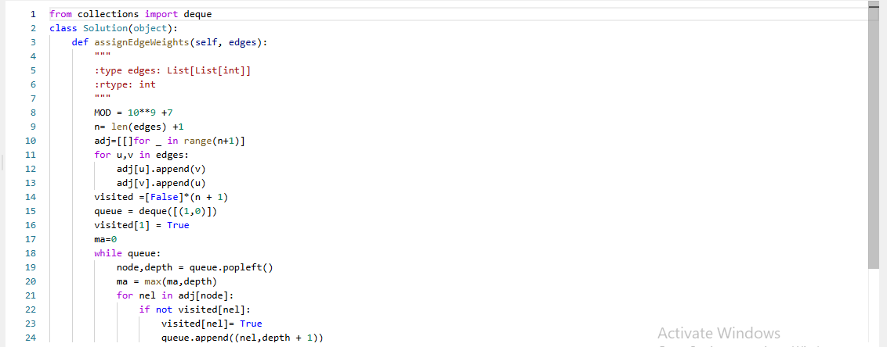
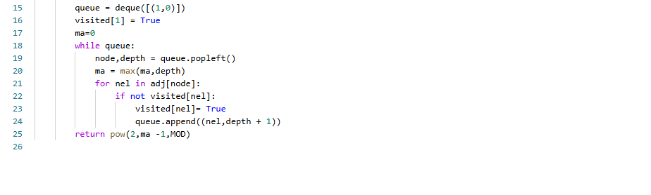

Algorithm
- Build the tree.
- BFS/DFS from root 1.
- Find maximum depth D.
- Return 2D−1 mod (109+7)2^{D-1} \bmod (10^9+7)2D−1mod(109+7).

Complexity
- Building tree: O(n)
- DFS/BFS: O(n)
- Fast exponentiation: O(log n)
Overall:
O(n)
